Assignment 2:

Info tech team project.

# Team name

Brave Mice

# Profile

## Comments:

Trevor: I really seriously doubt any of these idiotic tests or their stupendously irrelevant vague and inaccurate results will be of any use whatsoever to the group, nor to anyone or anything else in the entirety of existence, for the duration of all existence … it’s just utter horse shite, and about as meaningful as your star signs in a weekly magazine.

## Test outcomes:

### Trevor:

##### Learning style test:

Scores:

Auditory: 45%

Visual: 35%

Tactile: 20%

Auditory learner.

##### Myers Briggs:

The Protagonist ( ENFJ-A )

Individual traits:

Extraverted – 63%,

Intuitive – 85%,

Feeling – 64%,

Judging – 58%,

Assertive – 74%

Role:

Diplomat

Strategy:

People Mastery

##### IQ Test:

IQ score is: 139

### Travis:

##### Myers-Briggs:

Results:

[The Virtuoso](https://www.16personalities.com/istp-personality/) (ISTP-A / ISTP-T)

a Virtuoso is a person that loves to work on projects and pull things apart and put them back together again, it is a person that loves getting their hands dirty and has an unpredictable nature.

My individual traits show that I am:

Introverted – 64%

Observant – 61%

Thinking – 54%

Prospecting – 51%

Turbulent – 69%

##### Learning style test:

Results:

Auditory – 30%

Visual – 20%

Tactile – 50%

I am a Tactile Learner

##### Entrepreneurial Personality Profile:

Results:

You are fairly people-oriented, although you have the potential to improve your interpersonal skills even more. In order to be successful in the entrepreneurial field, you will need to create relationships with helpful business contacts, clients, suppliers, and employees. This requires strong interpersonal skills, and a certain degree of comfort initiating conversations and networking, all of which generally seem to be strengths of yours. You may want to consider taking classes to further brush up on your people skills and assertiveness skills, but overall, you are doing quite well in this area.

### Matthew:

##### Test 1:

Results:

##### Test 2:

Results:

##### Test 3:

Results:

### Zane:

##### Learning style test:

Visual/ tactile learner

##### Myers Briggs:

The Architect (INTP) and/or The Healer (INFP)

Individual traits:

Introverted – 60%,

Intuitive – 74%,

Feeling – 59%,

Perceiving – 60%,

You are sensitive, caring, and compassionate, and are deeply concerned with the personal growth of yourself and others. Individualistic and nonjudgmental, you believe that each person must find their own path. You enjoy spending time exploring your own ideas and values, and are gently encouraging to others to do the same. You are creative and often artistic, and enjoy finding new outlets for self-expression

##### Creativity:

68.11

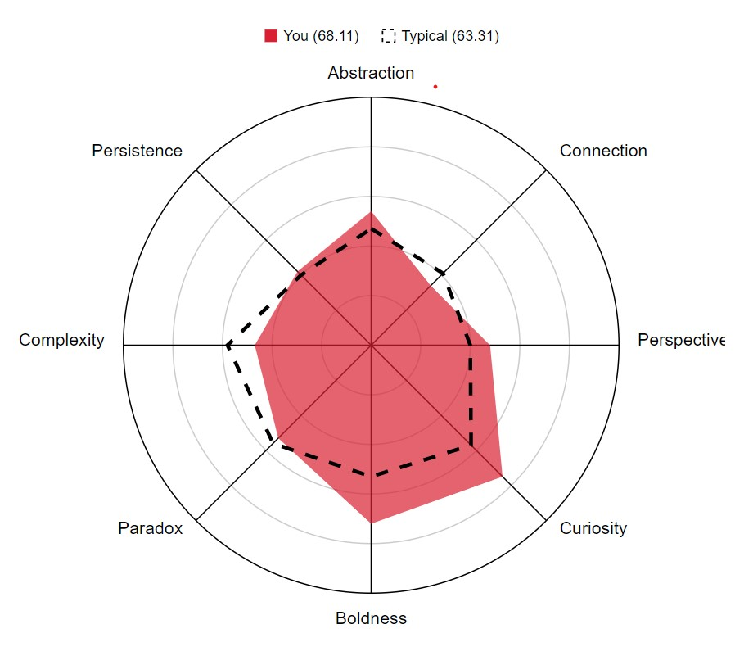

### Chinonso:

##### Test 1:

Results:

##### Test 2:

Results:

##### Test 3:

Results:

### Tony:

##### Test 1:

Results:

##### Test 2:

Results:

##### Test 3:

Results:

# Members

Trevor Rose – [s3223040@student.rmit.edu.au](mailto:s3223040@student.rmit.edu.au)

Done over 100 jobs in my life, 48 years old, raised in a tiny country town by 2 doctors, and I look like the love child of a hobbit with gigantism that shagged a Wookie after a big night out at the green dragon … I will likely become galactic president one day. I’ve sold 3D CAD/CAM/CAE/PDM software, and other software over the years … I grew up with electronics around me, worked as a cable tv and telephony installer, worked as a videowall technician, and a great many other relevant things too numerous to mention. I am interested in inventing things both in terms of software, networks, systems, devices, and machines.

Travis Anderson - [s3812502@student.rmit.edu.au](mailto:s3812502@student.rmit.edu.au)

I’m 26 years old, currently live and work in Sydney and have for the last 4 years, I grew up in Tamworth and have lived in Melbourne and Brisbane also. I have a Fiancé whom I have been with for 5 years and we both have a German Shepherd and two cats.

My hobbies include water skiing, photography, travelling, parachuting and gaming.

I have strong interests in Cybersecurity and intend to posture my future career towards achieving a role in this field. I have experience in digital forensics and have works overseas conducting these tasks on top of my regular work as a Systems Administrator.

I have 7 years’ experience in working in IT and have multiple industry certifications with primary focus towards Microsoft and Cisco. I have limited experience with software development and coding but would like to progress towards learning this. I have strong skills with network devices, security within IT and OS Installs/Patching/Upgrades.

Matthew Hughes - [s3816641@student.rmit.edu.au](mailto:s3816641@student.rmit.edu.au)

Blah blah blah blah blah blah blah blah blah blah blah blah blah blah blah blah blah blah blah blah blah blah blah blah blah blah blah blah blah blah blah blah blah blah blah blah blah blah blah blah blah blah blah blah blah blah blah blah blah

Zane Van Gramberg - [s3729079@student.rmit.edu.au](mailto:s3729079@student.rmit.edu.au)

I am 20 years old, born and raised in Mullumbimby, Australia. I’m half Sri-Lankan and half white fella but my family’s been here for a long time now so were as Australian as they get. I received a public high school education and although I never took interest in my education, I finished with a decent ATAR. Now that I’m in a course that interests me I will to put the effort in and set myself up for the future. Interestingly, despite pursuing a career with computers, I never learnt to touch type. I will remedy this while I complete this course. I am glad I get the opportunity to do this course online cause I love to travel. I plan to travel around Asia while I study.

Chinonso John Nkpolukwu - [s3819440@student.rmit.edu.au](mailto:s3819440@student.rmit.edu.au)

Blah blah blah blah blah blah blah blah blah blah blah blah blah blah blah blah blah blah blah blah blah blah blah blah blah blah blah blah blah blah blah blah blah blah blah blah blah blah blah blah blah blah blah blah blah blah blah blah blah

## Tony:

Blah blah blah blah blah blah blah blah blah blah blah blah blah blah blah blah blah blah blah blah blah blah blah blah blah blah blah blah blah blah blah blah blah blah blah blah blah blah blah blah blah blah blah blah blah blah blah blah blah

# Ideal jobs

## Trevor:

Blah blah blah blah blah blah blah blah blah blah blah blah blah blah blah blah blah blah blah blah blah blah blah blah blah blah blah blah blah blah blah blah blah blah blah blah blah blah blah blah blah blah blah blah blah blah blah blah blah

## Travis:

Blah blah blah blah blah blah blah blah blah blah blah blah blah blah blah blah blah blah blah blah blah blah blah blah blah blah blah blah blah blah blah blah blah blah blah blah blah blah blah blah blah blah blah blah blah blah blah blah blah

## Matthew:

Blah blah blah blah blah blah blah blah blah blah blah blah blah blah blah blah blah blah blah blah blah blah blah blah blah blah blah blah blah blah blah blah blah blah blah blah blah blah blah blah blah blah blah blah blah blah blah blah blah

## Zane:

Blah blah blah blah blah blah blah blah blah blah blah blah blah blah blah blah blah blah blah blah blah blah blah blah blah blah blah blah blah blah blah blah blah blah blah blah blah blah blah blah blah blah blah blah blah blah blah blah blah

## Chinonso:

Blah blah blah blah blah blah blah blah blah blah blah blah blah blah blah blah blah blah blah blah blah blah blah blah blah blah blah blah blah blah blah blah blah blah blah blah blah blah blah blah blah blah blah blah blah blah blah blah blah

## Tony:

Blah blah blah blah blah blah blah blah blah blah blah blah blah blah blah blah blah blah blah blah blah blah blah blah blah blah blah blah blah blah blah blah blah blah blah blah blah blah blah blah blah blah blah blah blah blah blah blah blah

# Personal profile links

## Trevor:

Blah blah blah blah blah blah blah blah blah blah blah blah blah blah blah blah blah blah blah blah blah blah blah blah blah blah blah blah blah blah blah blah blah blah blah blah blah blah blah blah blah blah blah blah blah blah blah blah blah

## Travis:

Blah blah blah blah blah blah blah blah blah blah blah blah blah blah blah blah blah blah blah blah blah blah blah blah blah blah blah blah blah blah blah blah blah blah blah blah blah blah blah blah blah blah blah blah blah blah blah blah blah

## Matthew:

Blah blah blah blah blah blah blah blah blah blah blah blah blah blah blah blah blah blah blah blah blah blah blah blah blah blah blah blah blah blah blah blah blah blah blah blah blah blah blah blah blah blah blah blah blah blah blah blah blah

## Zane:

Blah blah blah blah blah blah blah blah blah blah blah blah blah blah blah blah blah blah blah blah blah blah blah blah blah blah blah blah blah blah blah blah blah blah blah blah blah blah blah blah blah blah blah blah blah blah blah blah blah

## Chinonso:

Blah blah blah blah blah blah blah blah blah blah blah blah blah blah blah blah blah blah blah blah blah blah blah blah blah blah blah blah blah blah blah blah blah blah blah blah blah blah blah blah blah blah blah blah blah blah blah blah blah

## Tony:

Blah blah blah blah blah blah blah blah blah blah blah blah blah blah blah blah blah blah blah blah blah blah blah blah blah blah blah blah blah blah blah blah blah blah blah blah blah blah blah blah blah blah blah blah blah blah blah blah blah

# Team website

<https://bravemice.github.io/bravemice/>

# GitHub repo

<https://github.com/BraveMice/bravemice>

# Industry Data:

## Job titles

## Demand for jobs

## Required skill sets

## Skill demand ranking

### Top 3 ( general and specific )

## Reflection on ideal jobs following research

# Interview an IT professional

## OR Review 10 YouTube videos regarding industry roles

### Requires 5+ IT professionals from 10+ sources

## Answer these questions:

### What work is done by roles

### What kinds of people do they interact with

### Where do they spend their time

### What is most challenging about role

# IT Tech – report on 4 of the following:

## Cloud server/service

## Cyber security

## Blockchain / crypto

## Machine learning ( AI )

## Autonomous vehicles

## Natural language processors ( chatter bots )

## Robots / mechatronics

## Mini computers ( eg: raspberry pi )

### What do they do? ( 600 words )

#### What is state of the art in this tech

#### What can be done

#### What is coming soon

#### What technology makes it possible

### Likely impact of tech ( 300 words )

#### Potential impact

#### Likely changes

#### Who will be affected

#### How will they be affected

### How will it affect you ( 300 words )

#### Daily life

#### What will be different

#### Effect on family / friends

# Project ideas

## Group project

## < 500 words ( adequate )

## **Then:**

### Login to spark plus on canvas

### Assess other members of group

### Self review

## **Finally:**

### Group reflection ( 200 words per person )

### +400 group words

### GitHub commits

### Group process

### What went well

### What needs improvement

### One surprising thing

### Learning about groups

Harvard referencing

submit a single pdf ( with links as described )

I’ve just put this stuff below so if you want to copy and paste it into any section above as a starting point, it just gives you the heading styles and tab formatting ready to go

## Trevor:

Blah blah blah blah blah blah blah blah blah blah blah blah blah blah blah blah blah blah blah blah blah blah blah blah blah blah blah blah blah blah blah blah blah blah blah blah blah blah blah blah blah blah blah blah blah blah blah blah blah

## Travis:

Blah blah blah blah blah blah blah blah blah blah blah blah blah blah blah blah blah blah blah blah blah blah blah blah blah blah blah blah blah blah blah blah blah blah blah blah blah blah blah blah blah blah blah blah blah blah blah blah blah

## Matthew:

Blah blah blah blah blah blah blah blah blah blah blah blah blah blah blah blah blah blah blah blah blah blah blah blah blah blah blah blah blah blah blah blah blah blah blah blah blah blah blah blah blah blah blah blah blah blah blah blah blah

## Zane:

Blah blah blah blah blah blah blah blah blah blah blah blah blah blah blah blah blah blah blah blah blah blah blah blah blah blah blah blah blah blah blah blah blah blah blah blah blah blah blah blah blah blah blah blah blah blah blah blah blah

## Chinonso:

Blah blah blah blah blah blah blah blah blah blah blah blah blah blah blah blah blah blah blah blah blah blah blah blah blah blah blah blah blah blah blah blah blah blah blah blah blah blah blah blah blah blah blah blah blah blah blah blah blah

## Tony:

Blah blah blah blah blah blah blah blah blah blah blah blah blah blah blah blah blah blah blah blah blah blah blah blah blah blah blah blah blah blah blah blah blah blah blah blah blah blah blah blah blah blah blah blah blah blah blah blah blah